**Ideation – Define the Problem Statements**

**Project Name: Garage Management System**  
**Team ID**: LTVIP2025TMID31528

**IDEATION PHASE**

**Introduction**

The Ideation Phase is the foundation of any project development lifecycle. It focuses on identifying the core problem faced by users and understanding the needs, pain points, and opportunities. For the **Garage Management System**, the aim is to build a software system that helps manage the daily operations of a garage, including bookings, billing, vehicle records, inventory, and customer interaction.

**Define the Problem Statements**

**1. Manual Record Keeping**

**Problem:** Most garages still maintain paper-based records, which leads to difficulties in data retrieval, chances of loss or damage, and inefficient time usage.  
**Solution Idea:** Introduce a digital database system to record customer details, vehicles, service history, and payments.

**2. Lack of Customer Management**

**Problem:** Customers are not notified about service status, delays, or upcoming maintenance.  
**Solution Idea:** Develop an automated customer notification and reminder system using email or SMS.

**3. Unorganized Service Scheduling**

**Problem:** Garages often face confusion in scheduling repairs and maintenance due to overlapping appointments or lack of technician availability.  
**Solution Idea:** A centralized calendar or appointment system that allows for easy scheduling and staff allocation.

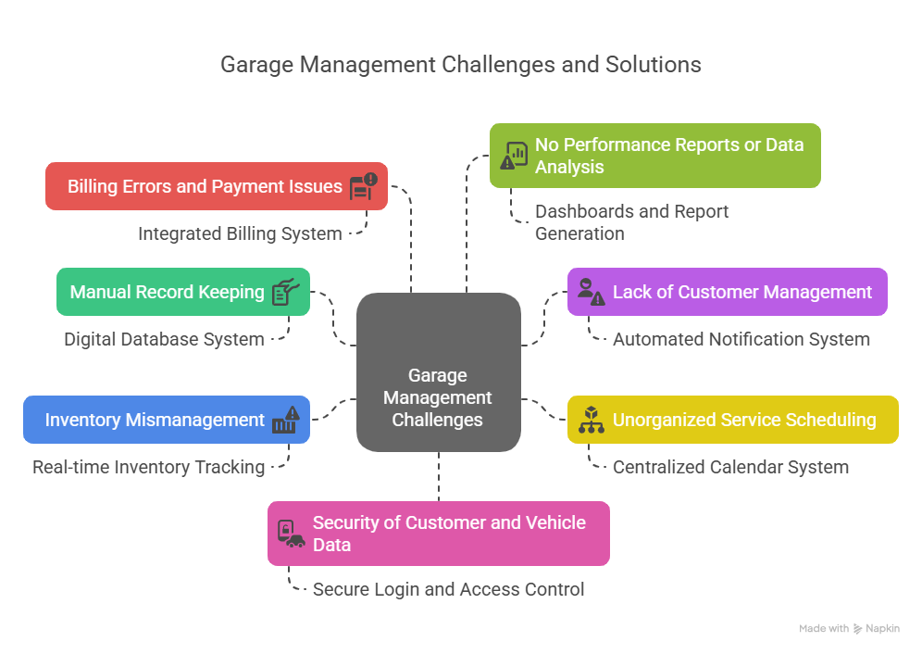

**4. Inventory Mismanagement**

**Problem:** Spare parts availability is often unknown until needed, leading to customer dissatisfaction and service delay.  
**Solution Idea:** Real-time inventory tracking and alert system when stock is low.

**5. Billing Errors and Payment Issues**

**Problem:** Manual calculations lead to incorrect billing or missing entries.  
**Solution Idea:** Integrated billing system with automated invoice generation and digital payment options.

**6. No Performance Reports or Data Analysis**

**Problem:** Garages lack analytical insights on sales, most used services, and technician performance.  
**Solution Idea:** Dashboards and report generation features for better decision-making and efficiency improvements.

**7. Security of Customer and Vehicle Data**

**Problem:** In manual systems, customer and vehicle data is not securely stored.  
**Solution Idea:** Secure login and role-based access control in a digital system.

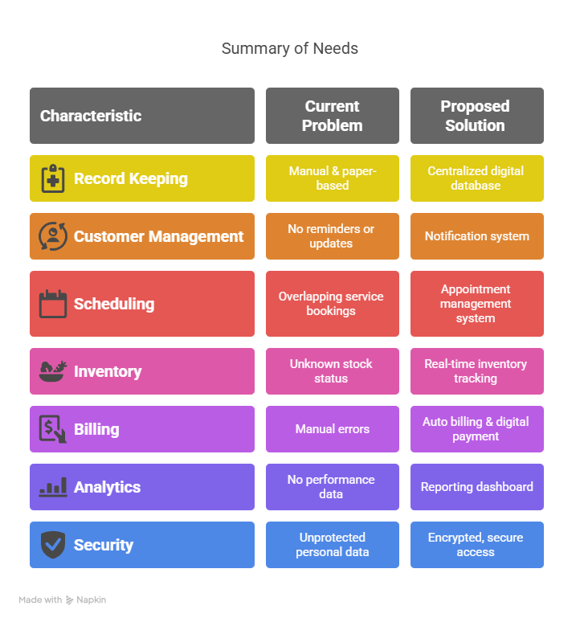

**Conclusion**

Clearly identifying the problems allows for focused solutions and a more efficient **Garage Management System**. Solving these pain points will benefit both garage owners and customers by improving service quality, organization, and overall satisfaction.